Updated Links
Fragments Microservice:
https://github.com/MansoorAZafar/fragments
Docker-file on GitHub:
https://github.com/MansoorAZafar/fragments/blob/main/Dockerfile
Docker Hub Fragments Repository:
https://hub.docker.com/r/mansoorazafars/fragments/tags

First Time Running Hadolint on Dockerfile
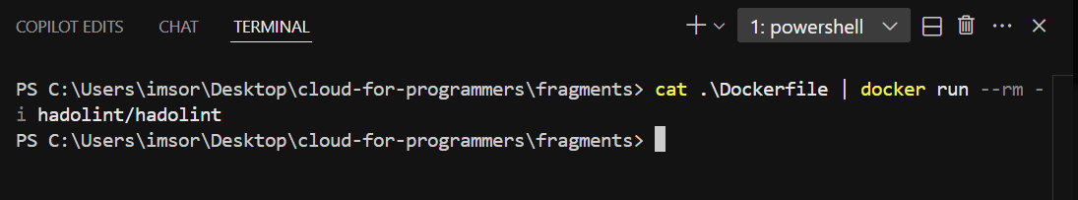
Successful CI Workflow for Dockerfile Lint & Docker Hub
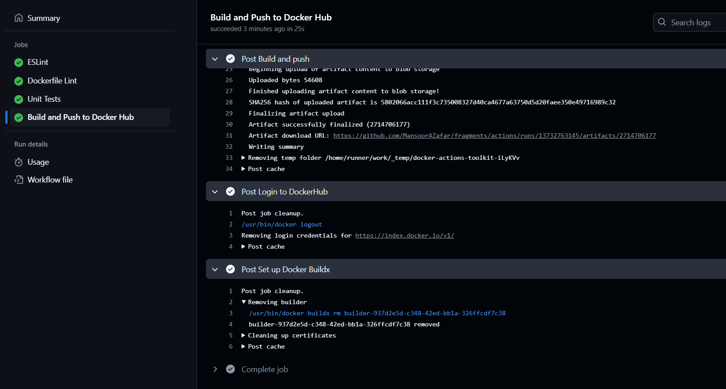
Main & Latest Tag in Docker Hub created by GitHub CI
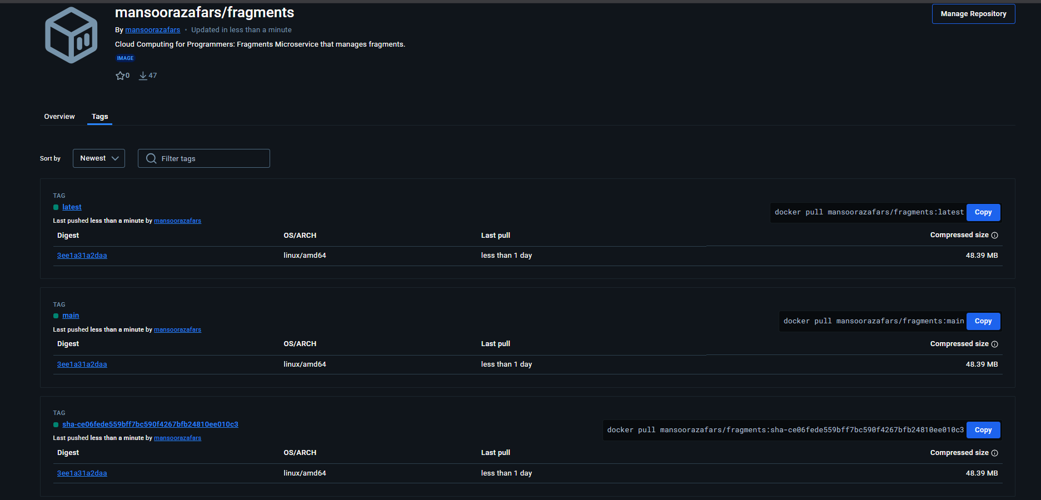
Successful CD workflow, AWS Login & Build and Push
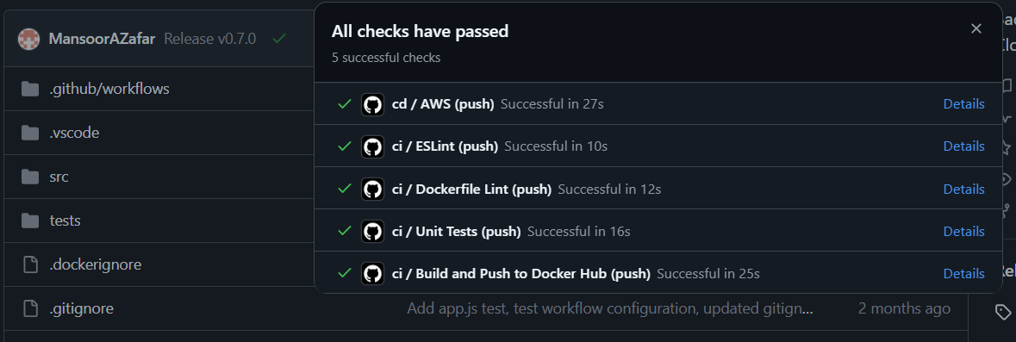
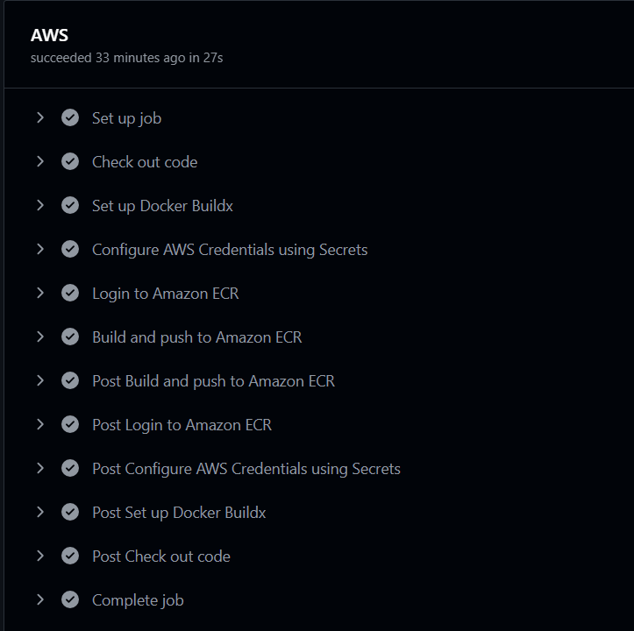
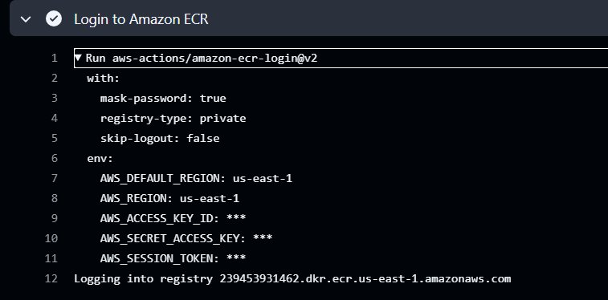
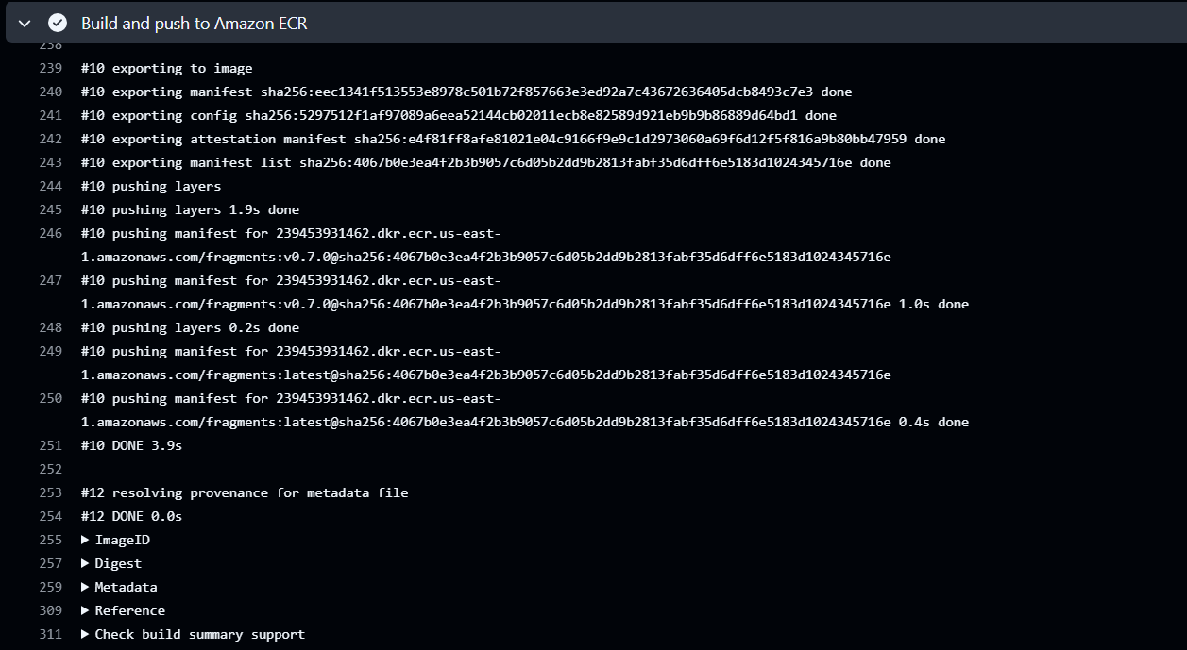
Amazon ECR fragments Image and tags
(On next page)
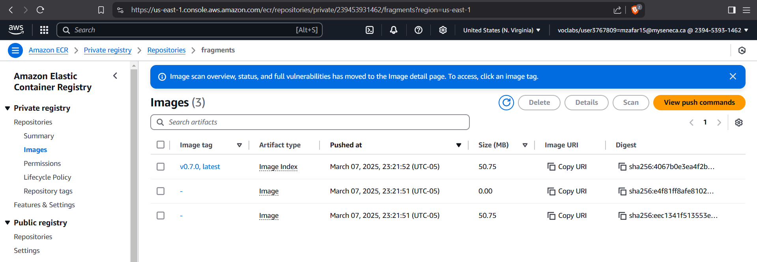

Local Machine Running main from Docker Hub built from GitHub Actions with health-check
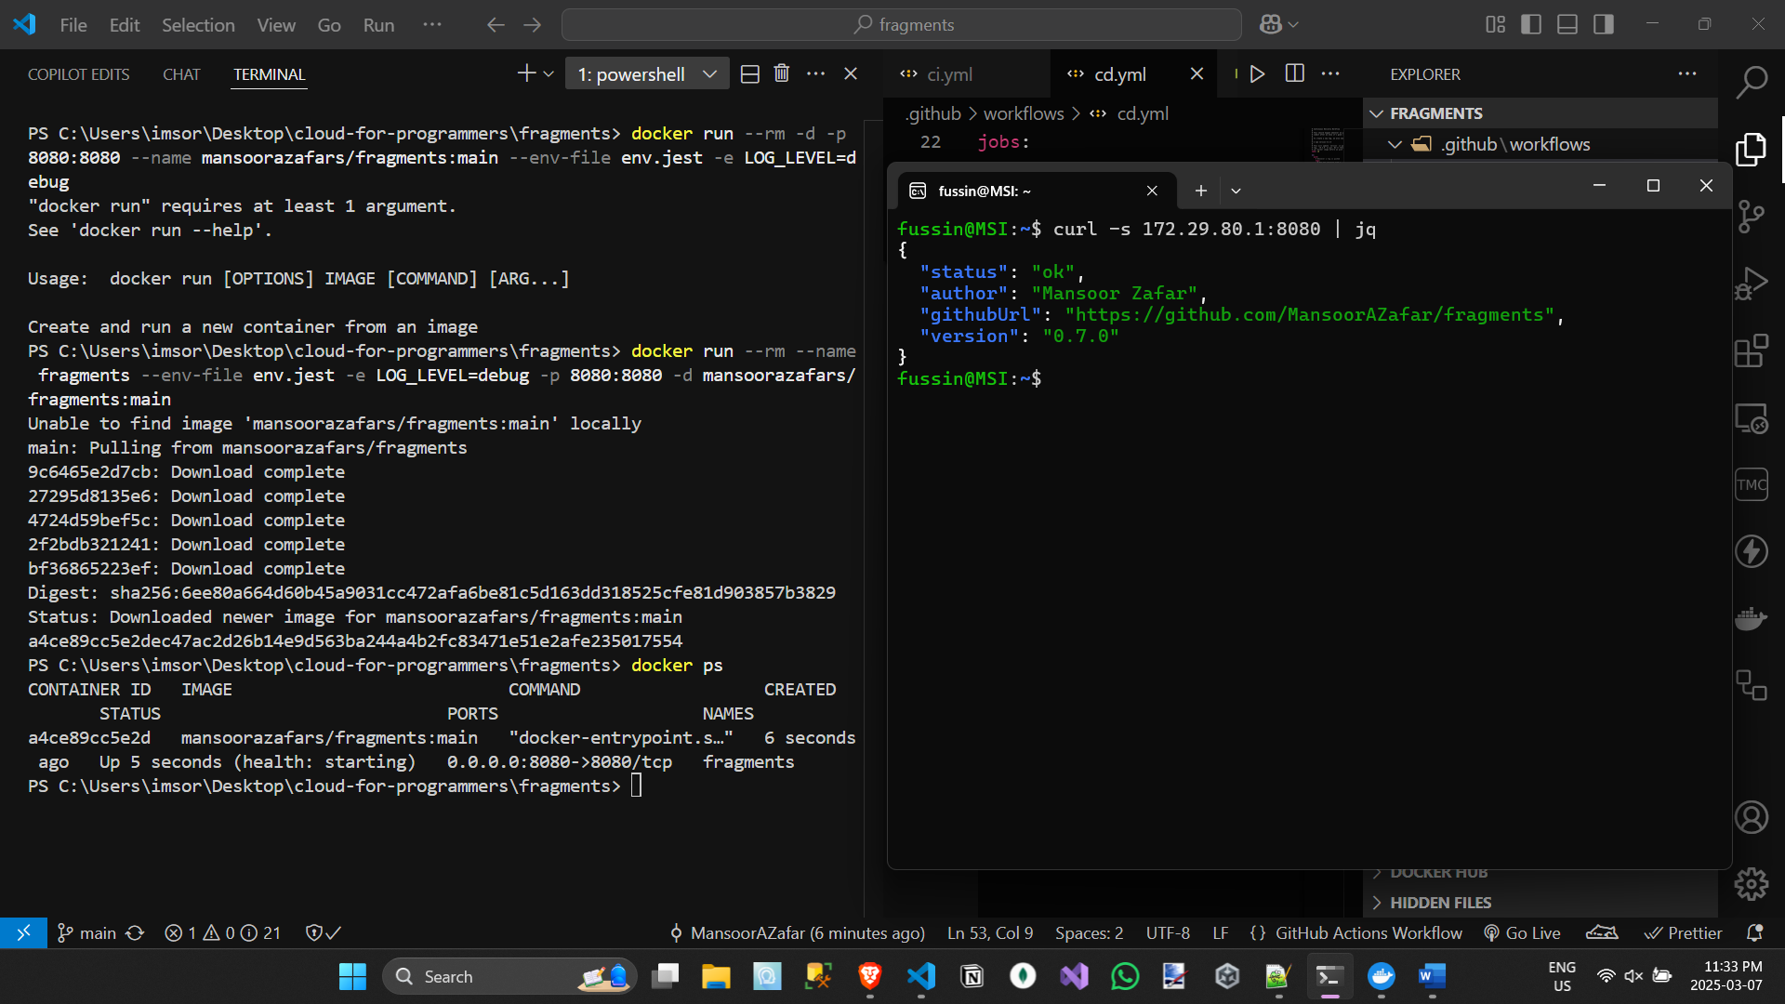

EC2 Running v0.7.0 from Amazon ECR fragments repository, built from GitHub Actions with health-check

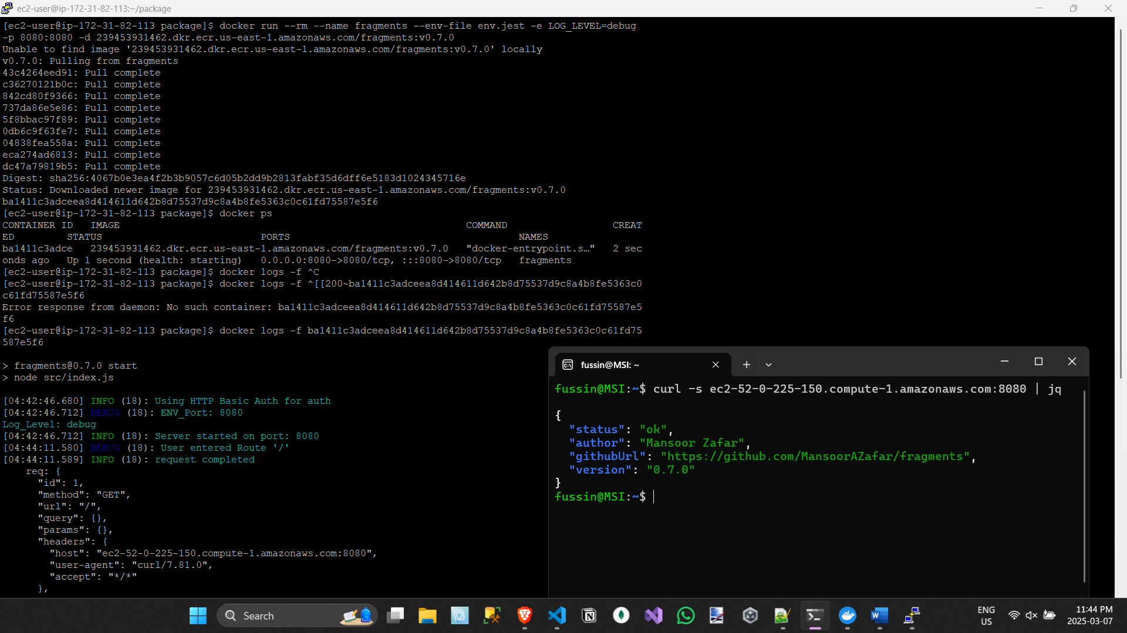
(more Zoomed in)
